**Tian Ci Lin**

PRE-LAB #8

Enzyme I “Affects by Temperature & Concentration”

for Students

Group 1

Section A2

Deandra, Raj, Alvin

10/23/2015

**Abstract**

This lab explores the effect of temperature and concentration on enzymatic reaction rates. Enzymes are proteins that chemical reactions in our cells. They are biocatalyst, which means that they speedup chemical reactions by lowering the activation energy. The activation energy is the required to put the reactants in a more reactive state called the transition state. It’s important to understand the different factors that affect enzymatic reactions, because most of the reactions in our cells use enzymes. Temperature is one important factor. Higher temperature increases the movement of molecules and the rate of reactions, but if the temperature is too high the enzymes will be hindered. Therefore, there is an optimal range of temperature for the enzymatic reaction (Vodopich).

**Materials**

* 3 water baths (40**°**C, 80**°**C, and 4**°**C)
* 3 test tube racks
* 7 test tubes
* Potato extract
* pH buffer,
* 1% catechol

**Procedure**

1. Prepare two water-baths, one at 40**°**C and one at 80**°**C. Place test tube rack in each and in an ice bath at 4**°**C.
2. Obtain seven test tubes, a tube of potato extract and a tube of 1% catechol.
3. Add potato extract, buffer, and distill water to the tubes in the table in the listed amounts.
4. Place the tubes in the baths they belong to. Leave tubes 1-4 in room temperature.
5. Add 1% catechol. Record color changes.
6. Make observations every 5 minutes.
7. Repeat with values in table for concentration

**Temperature test**

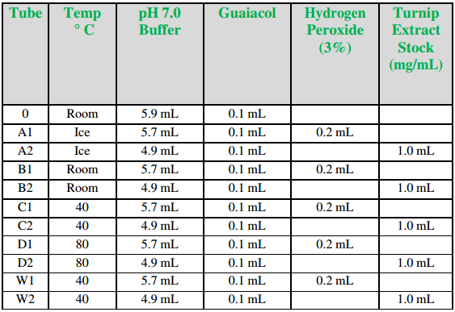

**Source - Exercise 8**

**Concentration Test**

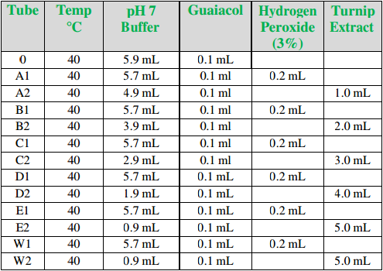

**Source - Exercise 8**

**Hypothesis**

The rate of reaction should be at a faster rate for 40**°**C compare with 80**°**C and 4**°**C. This is because 80**°**C is relatively too high and will destory the enzymes. 4**°**C is too low and will make the reaction slow. Therefore, the color change of the tubes in 40**°**C should be greater. The rate of reaction for higher concentration solution should be greater, because there are more reactants to react will, so the higher centration tubes will produce a greater change in color.

**Works Cited**

[**Beals, M., Gross, L., & Harrell**, *And*). Enzymes. Retrieved October 23, 2015](https://www.google.com/search?rlz=1C1VFKB_enUS659US659&es_sm=93&q=Beals,+M.,+Gross,+L.,+%26+Harrell,+And).+Enzymes.+Retrieved+October+23,+2015.&spell=1&sa=X&ved=0CBsQvwUoAGoVChMIn93u0d_YyAIVSjs-Ch35lgRj)

**Exercise 8 -** Enzyme I “Affects by Temperature & Concentration” for Students. (n.d.). Retrieved October 23, 2015, from https://newclasses.nyu.edu/access/content/group/1e25bd0d-ee48-40bf-9a9d-396f54977f51/Experiment 8 - Enzyme I Affects by Temperature _ Concentration Procedure.pdf

**Vodopich D, Moore R**. *Biology laboratory manual*. Boston: McGraw-Hill Higher Education, 2008.

**Tian Ci Lin**

Post-LAB #8

Enzyme I “Affects by Temperature & Concentration”

for Students

Group 1

Section A2

Deandra, Raj, Alvin

10/30/2015

**Data Collection:**

For experiment 1, the tube at room temperature had the highest absorbance, followed by the tubes at 40°C, Ice and 80°C. The tubes at 80°C had almost no absorbance value. The slope of the tube at room temperature is clearly the highest and the tube at 80°C had a slope of near zero.

For experiment 2, the tube E had the highest absorbance values followed by D, C, B, and A. The line for tube E is not a smooth curve.

Experiment 1: Temperature Factor

Room

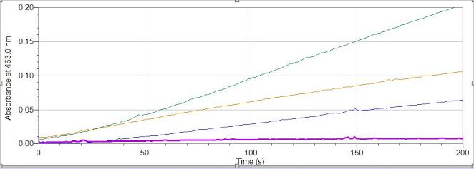

Ice

40°C

80°C

Figure 1: Experiment 1- Temperature Factor.

Blue = Tube A (ice) , Green = Tube B (room temp.), Yellow = tube C (40°C), Purple = tube D (80°C)

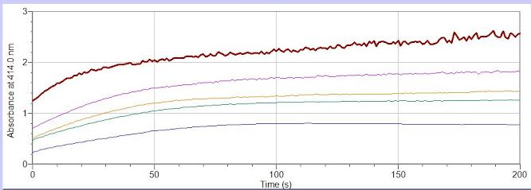

Tube A AAE\AA

Tube D

Tube B

Tube C

Tube E

Figure 2: Experiment 2- Concentration.

Blue = Tube A, Green = Tube B (room temp.), Orange/Yellow = tube C (40°C), Purple = tube D (80°C), Brown/red = tube E.

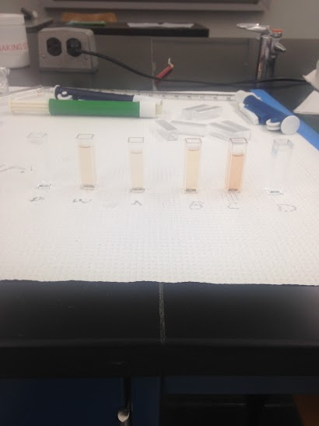

Figure 3: Experiment 1- test tube color results

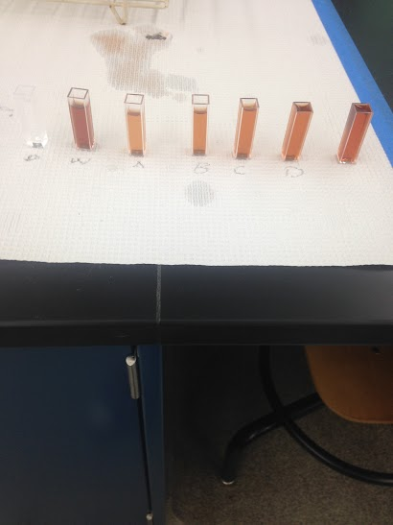

E

Figure 4: Experiment 2- test tube color results

**Conclusion:**

My hypothesis that 80°C has the least reaction was correct. The extreme temperature denatures the enzyme preventing them from having effect. However, the hypothesis that 40°C will have the highest reaction rate was incorrect. 40°C had the second highest reaction rate. The tubes at room temperature have the highest reaction rate as seen by the steeper slope in the graph. My hypothesis that tube E with the highest concentration will have the most reaction in experiment 2 is correct as seen by the dark brown color of test tube E in figure 4.

**Sources of Error:**

The solution wasn’t mixed well when the guaiacol was added. This potentially causes the solution to be not homogenous and the guaiacol is concentrated at the bottom. This causes a poor color result because the guaiacol is what causes the color change.

**Post Procedure:**

**Temperature:**

The temperature vs OD line is not straight because an increase an temperate is not linear to absorbance. Also, when the temperature is too high, the enzyme dentures causing no reaction and no absorbance.

**Concentration:**

The concentration vs OD line is straight until the concentration reaches a maximum effect. This is because the increase in concentration of enzyme causes a linear increase in absorbance. But when there is too much enzyme the increase stops. There is not enough substrate to bind with the excess enzymes.

**Works Cited**

[**Beals, M., Gross, L., & Harrell**, *And*). Enzymes. Retrieved October 23, 2015](https://www.google.com/search?rlz=1C1VFKB_enUS659US659&es_sm=93&q=Beals,+M.,+Gross,+L.,+%26+Harrell,+And).+Enzymes.+Retrieved+October+23,+2015.&spell=1&sa=X&ved=0CBsQvwUoAGoVChMIn93u0d_YyAIVSjs-Ch35lgRj)

**Exercise 8 -** Enzyme I “Affects by Temperature & Concentration” for Students. (n.d.). Retrieved October 23, 2015, from https://newclasses.nyu.edu/access/content/group/1e25bd0d-ee48-40bf-9a9d-396f54977f51/Experiment 8 - Enzyme I Affects by Temperature _ Concentration Procedure.pdf

**Vodopich D, Moore R**. *Biology laboratory manual*. Boston: McGraw-Hill Higher Education, 2008.